Electric Circuits & Electronics Design Lab

EE 316-01

# Lab 6: AC Signals, Transformers and Bridge Rectifiers

By: Jaiden Gann

Lab Section 316-01

Lab Date: 6/29/22

Lab Due: 7/12/22

## Introduction:

The purpose of this lab is to examine AC signals and how transformers and diodes can be used to rectify sine waves. This report will have 5 main sections. First is the theoretical analysis which is done as the pre-lab and includes Multisim simulations and handwritten solutions to the circuit. Then we have the physical circuits which are constructed on breadboards in lab. Afterwards, we compare the results from those 3 sections and conclude with an analysis of the results.

## Theoretical Analysis:

To begin, we look at the different ways we can calculate the RMS value of voltage shown in Figure 1, which is the way we report AC voltage. Next we look at transformers shown in Figure 2, which are used to step up or down AC voltages and currents. This process occurs because of the induced EMF that occurs on the input side between the transformer and magnetic coupling. The input side is referred to as the primary side and the output the secondary. The secondary side is made up of two coils, that if wound in different directions allows for two different output voltages. At least one output will be twice that of the other. Ideally a transformer is governed by the equations shown in Figure 3.

Next, we briefly look at a full wave rectifier and the effect it has on the output and ripple frequency which arises from AC components in the rectified signal. The average DC value of a rectified signal can be found using the equation and ripple frequency is where TRipple is the period of the waveform.

For this section, we drew the voltage waveforms at node A for two cycles and at nodes C and D for two cycles referring to Figure 4. We observed the difference in phase and then referring to Figure 5, figured out which parts of the wave were contributed by nodes C and D, the DC value of VOUT, and the ripple frequency. This work can be seen in Appendix 1.

**Figure 1**. RMS Voltage Equations

**Figure 2.** Transformer

**Figure 3.** Ideal Transformer Equations

**Figure 4**. Simple Transformer

**Figure 5.** Transformer with Bridge Rectifier

## Simulations:

For the next phase of the lab, we built the circuits from Figures 4 and 5 in Multisim which are shown in Figure 6 and 9. We used the TS_IDEAL transformer and noted the relationship between the secondary and primary voltage and the phase relationship for just the transformer. Then after adding the bridge rectifier we calculated the VOUT for DC, the ripple frequency, and compared the voltmeter reading to the oscilloscope. The readings and analysis are provided after the figure of each respective circuit.

**Figure 6**: Transformer (Figure 4 reference)

**Figure 7.** Oscilloscope at nodes A and C

Channel A is node A and channel B is node C. The markers should be at the peak voltages for each. It didn’t look like the secondary was 10x less than the primary, it looked to be more than that. They are in phase, maybe slightly off just a tad from looking at where the peak voltages line up. The frequency is around 62.5 Hz, found by doing 1/(16.452 ms).

**Figure 8.** Oscilloscope at C and D

Channel A is node D and Channel B is Node C. The waveforms are now out of phase, this implies the coils are in opposite directions.

**Figure 9**. Transformer with Bridge Rectifier (Figure 5 reference)

**Figure 10.** Oscilloscope Voltage Output

VOUT = 2(15.496)/ = 9.549. The multimeter output was 9.535 shown in Figure 9, which is pretty much what the oscilloscope gave. The period is 8.353 ms., which makes frequency 119.72 HZ. For a full bridge rectifier, the ripple frequency is twice that of the input so ripple frequency would be about 238 Hz.

## Experimental:

For the last portion of the lab, we did the same things as prior but on a physical board to further validate the output results we obtained. To note, the in-lab transformers had an 8:1 turn ratio whereas the theoretical and simulation one had a 10:1 turn ratio. We attached the oscilloscope to the two wires on the in-lab transformer which were synonymous with the simulation portion of the oscilloscope on nodes C and D. The output is shown in Figure 11. Then we built the bridge rectifier and attached the transformer to the beginning of it along with the multimeter. Those outputs are shown in Figure 12 and 13.

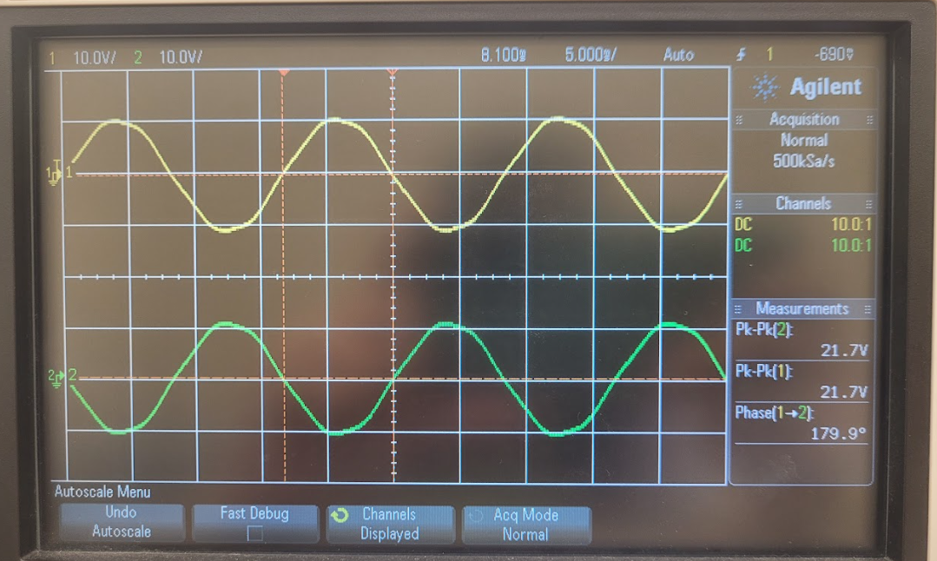

**Figure 11.** Transformer Output (Nodes C and D)

**Figure 12.** Transformer with Bridge Rectifier Output

**Figure 13.** Multimeter Output for Transformer with Bridge Rectifier

## Results and Discussion:

The results for this lab matched our expectations. From the experimental output of nodes C and D, we see that the two waveforms add up to around 45 Vpp which is what we were looking for. The waveforms are also out of phase which we noted in the previous two sections. The frequency is around 200 Hz found by 1/(5ms) for node D and around 123 Hz for node C, found by doing 1/(8.1ms). When calculating the output voltage in DC, the oscilloscope isn’t matching the multimeter which may be due to the measurements recorded or the usage of the wrong equation. To find the DC voltage, I took half of Vpp which makes Vpeak 11.05. Then multiplying that by 2 and dividing by pi gives you 7.03 which is about a voltage more than what the multimeter gives.

## Conclusion

Overall, the results of lab where in line with what we expected from the information gathered from the theoretical and experimental sections. It showed us how a transformer affects AC signals and how a bridge rectifier changes those signals. All together the lab gave a better physical representation of what a transformer and bridge rectifier do in a practical sense.

## Appendix 1:

## Appendix 2:

Signed lab results

N/A

Pictures of Circuits

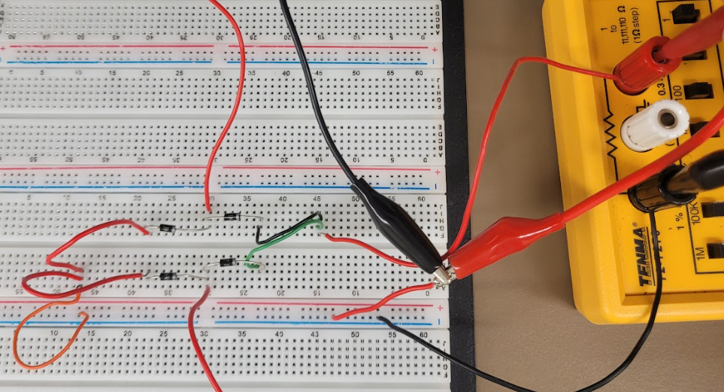

Figure 1. Transformer with Bridge Rectifier